

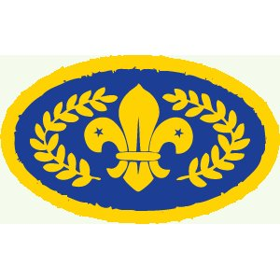 | Robyn Emerson | Hannah Waving | Lucy Goddard | Hannah Adams | Imogen Adams | John Carfrae | Sa Nye | Fola Brady | James Rowland | Seamus Callaghan-Kells | Max Syer | Daniel Hick | Harry King | Sam Clutterbuck | Carlo Simone | Charlie Cox | Adam Pearson | Hannah Warnock | Ellie Brumbaugh | Amy Fitzgerald | Felix Friend | Dylan Willis | James Martin | Alfie Nye | Bradley Edney | Ben Rowland | Hannah Clark | Fred Caudwell | George Caudwell | Laura Shimmins | Zayon Soares | Ryan Clark
This badge is the highest award available in the Scout Section.
It is gained by completing:
The Community Challenge
The Fitness Challenge
The Creative Challenge
The Global Challenge
The Promise Challenge
The Outdoor Challenge |  |  |  |  |  |  |  |  |  |  |  |  |  |  |  |  |  |  |  |  |  |  |  |  | 
And two of the following:
The Outdoor Plus Challenge
The Adventure Challenge
The Expedition Challenge

If a Scout has not quite completed the requirements for the top award before they move on to the Explorer Scout Unit, they may complete it in their early weeks in the Explorer Scout Unit.

Chief Scout’s Gold Award

