

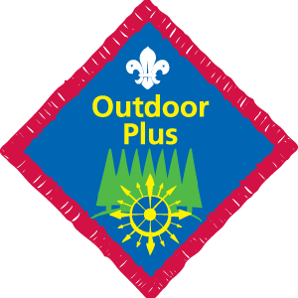 | Robyn Emerson | Hannah Waving | Lucy Goddard | Hannah Adams | Imogen Adams | John Carfrae | Sam Nye | Fola Brady | James Rowland | Seamus Callaghan-Kells | Max Syer | Daniel Hick | Harry King | Sam Clutterbuck | Carlo Simone | Charlie Cox | Adam Pearson | Hannah Warnock | Ellie Brumbaugh | Amy Fitzgerald | Felix Friend | Dylan Willis | James Martin | Alfie Nye | Bradley Edney | Ben Rowland | Hannah Clark | Fred Caudwell | George Caudwell | Laura Shimmins | Zayon Soares | Ryan Clark
The Scout must 1. Hold the Outdoor Challenge; 2. Have spent at least eight nights away as a Scout, four of which must be camping; 3. Take an active part in further camp(s), which should include many of the following;
Lead or help lead setting up of Scout campsite
Plan a balanced menu for a short camp
Show how to safely use an axe and/or saw
Lead the cooking of a meal for the Group
Show knowledge of safety precautions for use of lamps & stoves
Cook a backwoods meal with the group
Build a working camp gadget, such as an alter fire, gateway etc
Take a lead role in construction of a pioneering project
Build a bivouac and sleep in it.
This list gives an idea of the type and style of the activities that the nights away should include.
Depending on the activity there may be extra ideas that could be included, which can be agreed in the Troop forum.
In addition to the above, demonstrate knowledge in emergency aid for the outdoors and be able to:
Demonstrate how to open an airway and give CPR.
Know how and when to put a patient in the recovery position.
Know how to recognise and treat fractures and severe bleeding.
Know how to use direct pressure to stop bleeding.
Demonstrate an awareness of the dangers of temperature extremes such as sunstroke, dehydration, heat exhaustion and hypothermia and know how to prevent and treat them.

Outdoor Plus Challenge

