

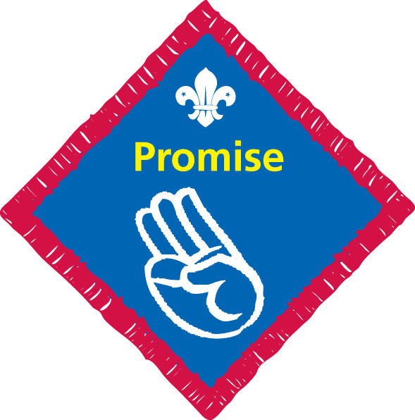 | Robyn Emerson | Hannah Waving | Lucy Goddard | Hannah Adams | Imogen Adams | John Carfrae | Sam Nye | Fola Brady | James Rowland | Seamus Callaghan-Kells | Max Syer | Daniel Hick | Harry King | Sam Clutterbuck | Carlo Simone | Charlie Cox | Adam Pearson | Hannah Warnock | Ellie Brumbaugh | Amy Fitzgerald | Felix Friend | Dylan Willis | James Martin | Alfie Nye | Bradley Edney | Ben Rowland | Hannah Clark | Fred Caudwell | George Caudwell | Laura Shimmins | Zayon Soares | Ryan Clark

Complete five activities in total, taken from at least two areas. Examples are provided below but other similar activities can also be undertaken.

Area 1 – Commitment to Law and Promise
- Explain how you have recently ‘done your best’ on at least three occasions and how this has made a difference.
- Explain to a new Scout in your Troop the meaning of the Scout Promise and Law.
- Assist with the planning and take part in an investiture ceremony or similar.
- Demonstrate that you can be trusted by taking on a special responsibility on behalf of the Troop. This might involve the management of money, or the Troop’s reputation.
Area 2 – Relationship with God
- Take part in a number of acts of worship with others in the Troop, such as Scout Parades at your place of worship and / or Scouts’ Own.
- Complete a course that furthers your understanding of your own faith community.
- Choose and read prayers and / or reflections for your Troop’s opening and closing ceremony.
- Hold the My Faith activity badge.
Area 3 – The life of the Troop
- Take an active part in at least two Troop Forums and express your views on at least one item being discussed.
- Contribute to the writing or reviewing of your Troop’s ‘Code of Conduct’.
- Play a full part in at least two Troop Leadership Forums and help implement the decision of the forum.
- Successfully run a learning experience for other Scouts.
- Successfully lead a group of Scouts at a two-day camp or other similar event. |  |  |  |  |  |  |  |  |  |  |  |  |  |  |  |  |  | 
Area 4 – Developing beliefs and attitudes
- Honestly review an event or activity and decide how it might be done better in the future.
- Visit an act of worship of another faith community and compare the traditions and customs with your own. |  |  |  |  |  |  |  |  |  |  |  |  |  |  |  |  |  |  |  |  |  | 
- Investigate a political or world issue, such as climate change, smoking, fair trade and explain your views to others.
- Take part in a debate on a topic of local or national interest.
- As a Scout, give freely of your time to help someone less fortunate than yourself.

Promise Challenge

